Homework 6 Synthetic Aperture Imaging

Yongchi Zhang

**1. Capture an unstructured light field**

We captured a scene with a few objects at different depths, moving the camera in a zig-zag motion. The video has been uploaded as “VID_20171129_194909.mp4”.

**2. Register the frames of video using template matching**

We wrote a matlab program to load in the video and convert the frames to grayscale. The blue box in the figure shows the template that was used for registration.

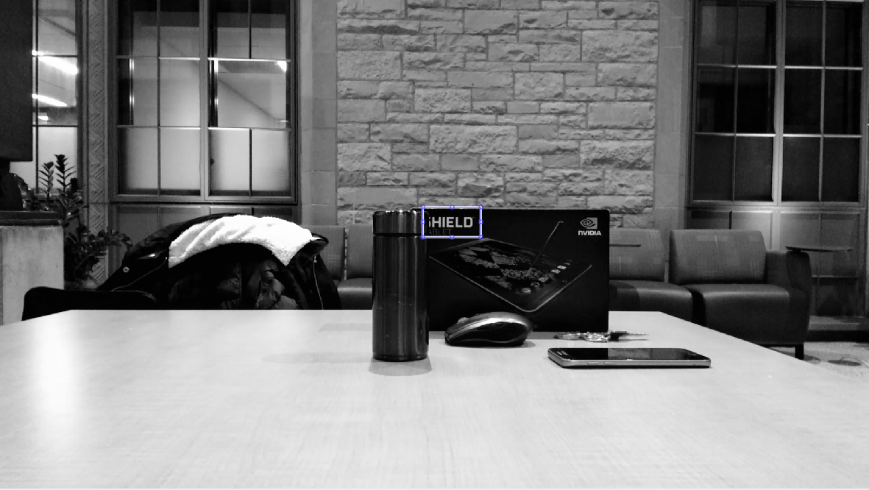

**Figure 1: The blue box shows the template that is used to register the video frames**

We searched for a template match within a window of your target frame. The window should be centered on the location of the template in the first frame. The size of the window should be slightly larger than the sum of the template size and the maximum shift of the target object over the entire set of video frames.

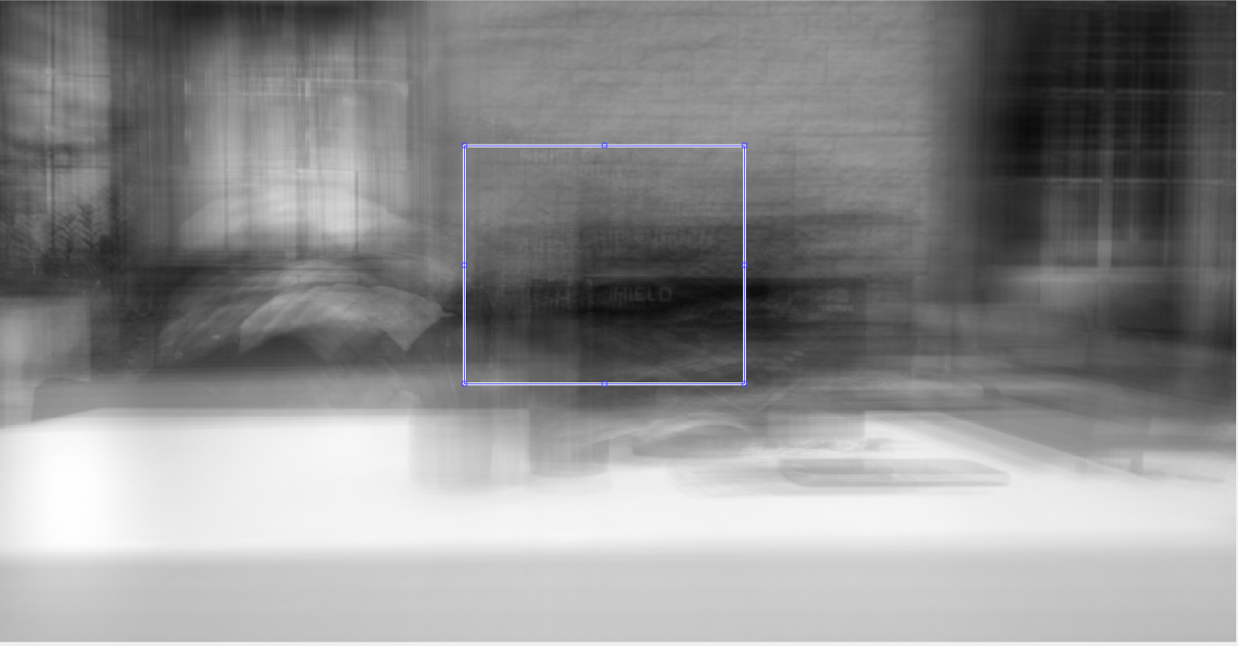

**Figure 2: Search within a window of the target frame for a match to the template**

We plot of the pixel shift for each frame.

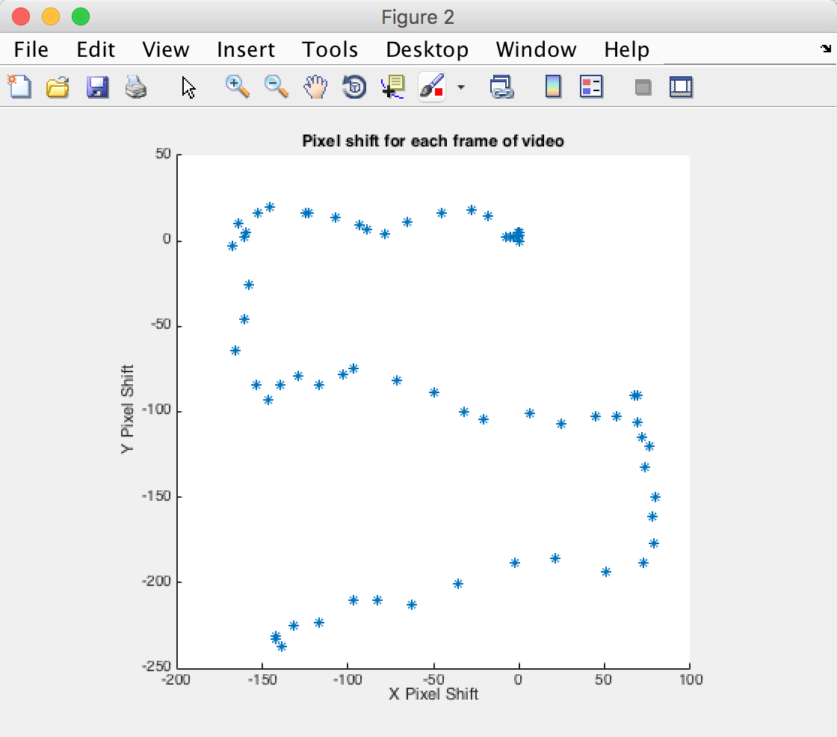

**Figure 3: The pixel shifts for the video**

**3. Create a synthetic aperture photograph**

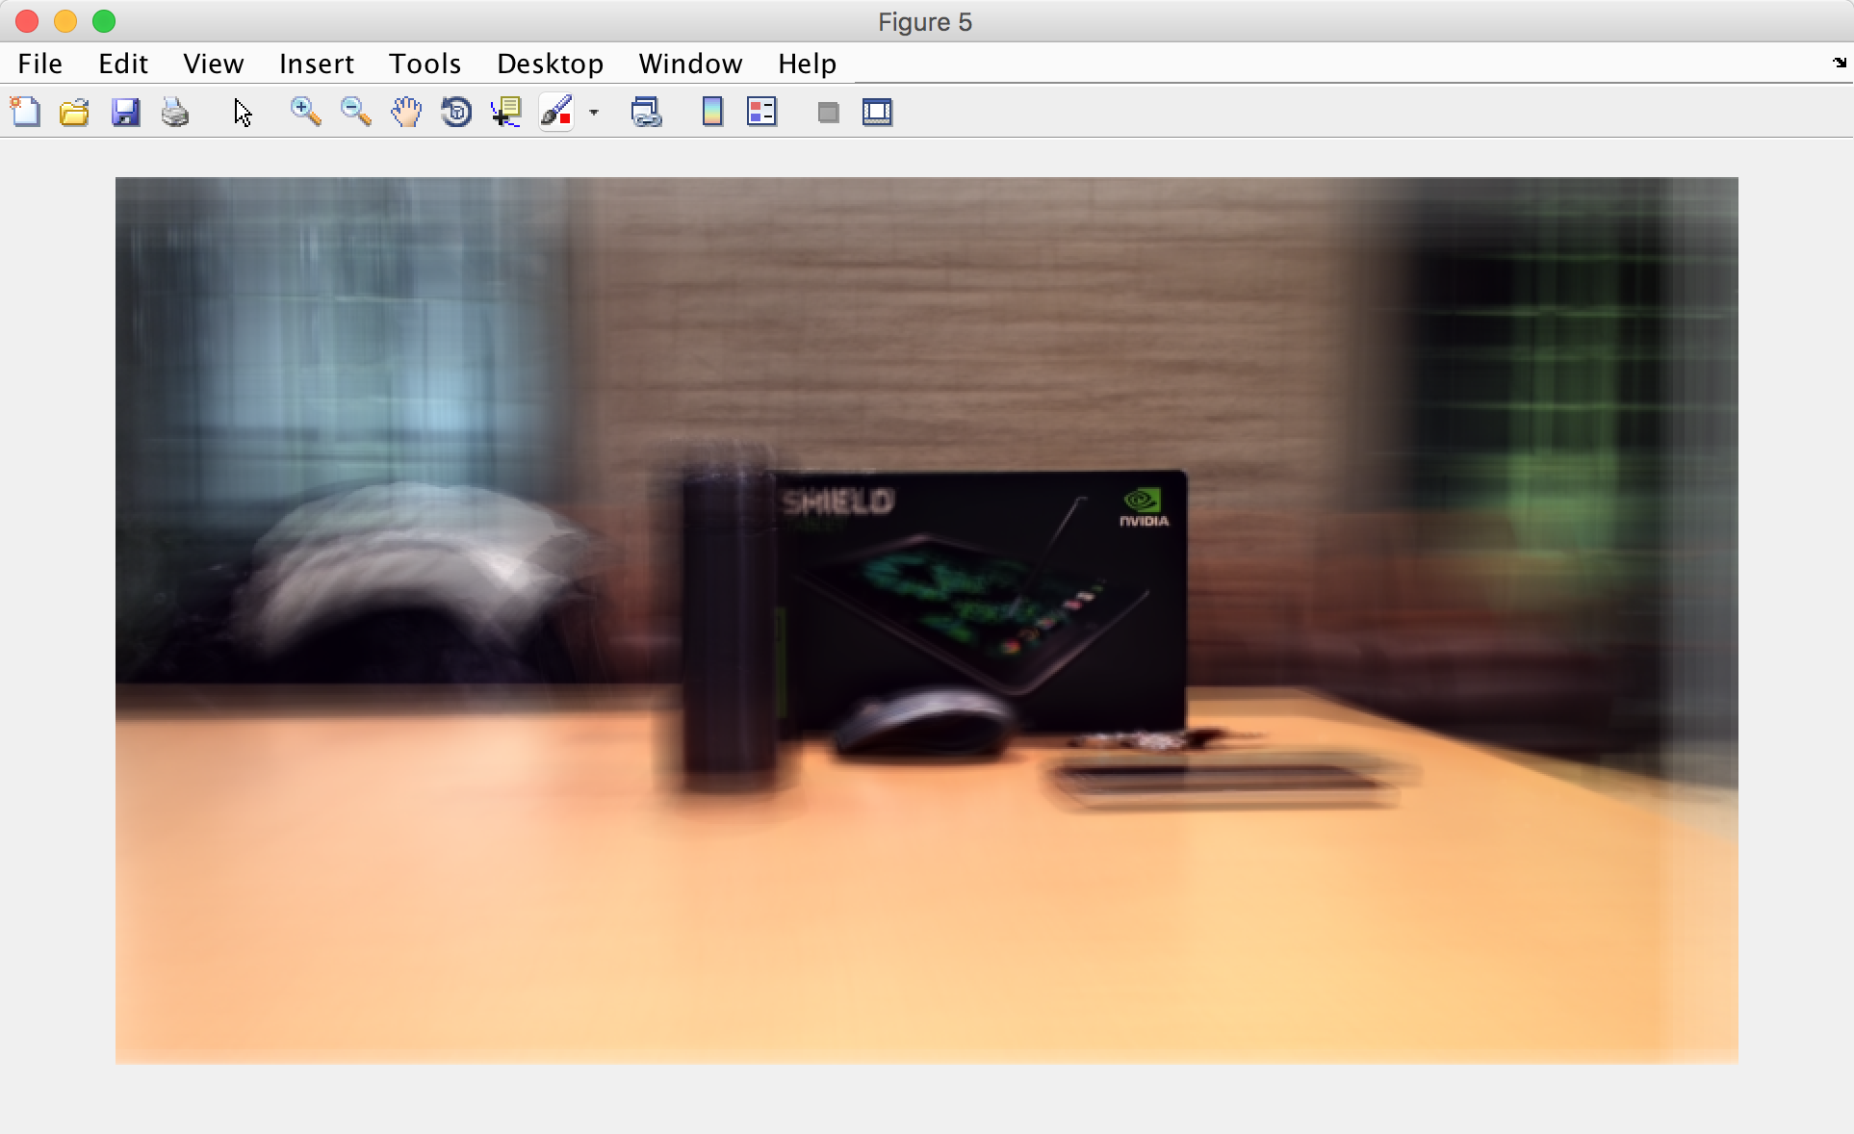

**Figure 4: A synthetic aperture photograph using a template from the box behind**

**4. Refocus on a new object**

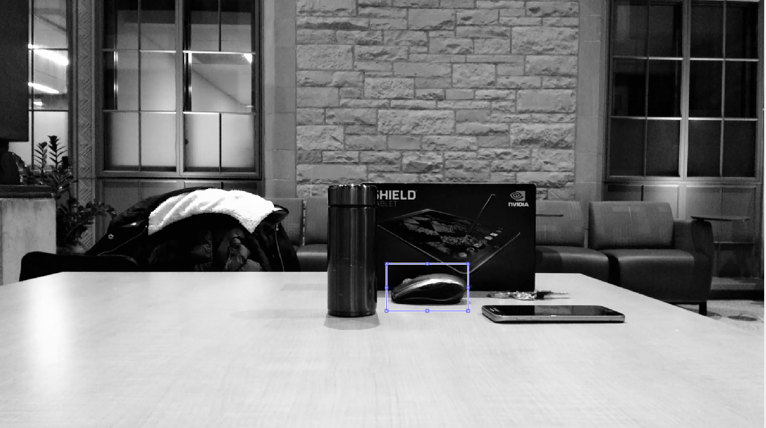

**Figure 5: Using a new template**

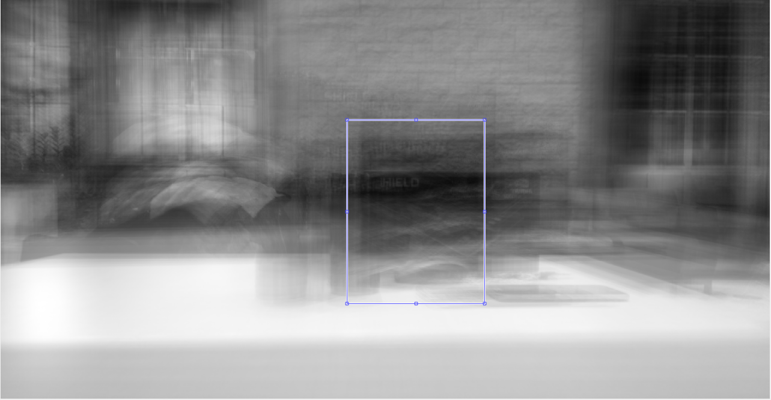

**Figure 6: Search within a window of the target frame for a match to the template**

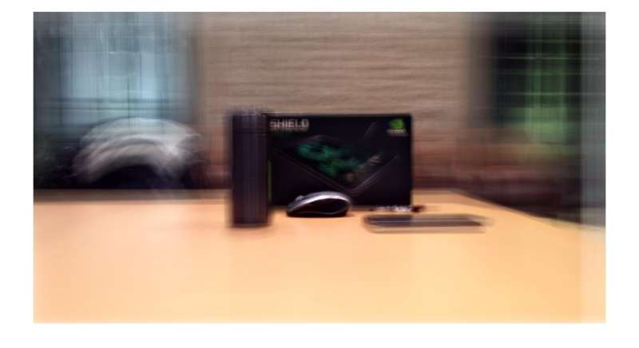

**Figure 7: A synthetic aperture photograph using the new template**